Voice Assistant using Python

A

**MINOR PROJECT REPORT**

*Submitted in partial fulfillment of the requirements*

*for the award of the degree of*

**BACHELOR OF TECHNOLOGY**

In

**Computer Science and Engineering**

Submitted to



**RAJIV GANDHI PROUDYOGIKI VISHWAVIDYALAYA,**

**BHOPAL (M.P.)**

Submitted by

Name: Roll no.:

**Rahul Patle 0115CS221092**

**Subhash Kushwaha 0115CS221125**

**Tushar Lihare 0115CS221136**

**Vinay Bisen 0115CS221143**

Under the Guidance of

**PROF. Vibhav Patel**



**DEPARTMENT OF COMPUTER SCIENCE AND ENGINEERING**

**NRI INSTITUTE OF INFORMATION SCIENCE & TECHNOLOGY BHOPAL**

**July to Dec – 2024**

**NRI INSTITUTE OF INFORMATION SCIENCE &**

**TECHNOLOGY BHOPAL**

**DEPARTMENT OF COMPUTER SCIENCE AND ENGINEERING**

**DECLARATION**

We hereby declare that the Project entitled “**Voice Assistant using Python**" is our own work conducted under the supervision of **Guide PROF. ‘Vaibhav Patel’, Designation, Department of Computer Science & Engineering** at **NRI Institute of Information Science & Technology, Bhopal**.

We further declare that to the best of our knowledge this report does not contain any part of work that has been submitted for the award of any degree either in this institute or in other institute without proper citation.

**Rahul Patle 0115CS221092**

**Subhash Kushwaha 0115CS221125**

**Tushar Lihare 0115CS221136**

**Vinay Bisen 0115CS221143**

**NRI INSTITUTE OF INFORMATION SCIENCE &**

**TECHNOLOGY BHOPAL**

**DEPARTMENT OF COMPUTER SCIENCE AND ENGINEERING**

**CERTIFICATE**

This is to certify that the work embodied in this project entitled **“Voice Assistant Using Python"** being submitted by **Name: Rahul patle, Subhash Kushwaha, Tushar Lihare, Vinay Bisen and Roll No. 0115CS221092, 0115CS221125 ,0115CS221136, 0115CS221143** in partial fulfillment of the requirement for the award of the degree of the Bachelor **of Technology (Computer Science and Engineering)** to Rajiv Gandhi Proudyogiki Vishwavidyalaya, Bhopal (M.P.) is a record of Bonafide piece of work, carried out by them under our supervision and guidance in the **Department of Computer Science and Engineering**, **NRI Institute of Information Science and Technology, Bhopal (M.P.).**

**Guided By Approved By**

**Prof. Vaibhav Patel Project In-charge**

**Assistant Professor Computer Science and Engineering   
NIIST, Bhopal NIIST, Bhopal**

**Director/ Principal**

**NIIST, Bhopal**

**ACKNOWLEDGEMENT**

Now a days the home security system is very poor. This project is consisting of a smart door lock

system in this we developed on a great solution to improve the home safety system. Arduino IDE

software in this we used Bluetooth devices to operate the door lock-in the home by using Smar phone. In our research we presented a part of smart home technology which using Bluetooth in a

mobile device, so it will easier and more efficient to use. It also based on Android and Arduino platform both of which are free open-source software. The safety in the house is very important. This project presents a prototype smart door locking which can be used to enhance security of a door. Here we are utilizing Bluetooth technology to scan Bluetooth Devices at the door knob for automatic door lock purposes.

In our project we presented a part of smart home technology which using Bluetooth in a mobile device, so it will easier and more efficient to use. It also based on Android and Arduino platform both of which are free open-source software. Security has become a major concern in the twenty first century; everybody wants to feel safe at his or her own home, workplace and a safe environment as a whole.

Smart door security system using Arduino and Bluetooth application is a project aimed at increasing and advancing the safety and security of lives and property of the people. In this, a system called door locks automation system using Bluetooth-based Android Smartphone is proposed and prototyped. First the hardware design and software development are described, then the design of a Bluetooth-based Smartphone application for lock/unlock the door are presented. The hardware design for door-lock system is the combination of android smart phone as the task master, Bluetooth module as command agent, Arduino microcontroller as controller canter / data processing canter, and solenoid as door lock output.

**ABSTRACT**

In today's dynamic world, where weather conditions significantly influence various aspects of daily life, accurate and timely weather forecasting has become indispensable. This minor project aims to develop a comprehensive Weather Forecast Application that leverages advanced technologies to provide real-time weather updates and detailed forecasts. The application is designed to serve multiple sectors, including agriculture, transportation, energy management, and public health, by offering specialized weather data and alerts.

The key features of the application include user authentication, real-time weather data retrieval, and the display of current conditions along with hourly, daily, and weekly forecasts. The application integrates geolocation services to provide localized weather information and supports multiple locations for user convenience. Furthermore, it generates severe weather alerts and sends timely notifications to help users prepare for extreme weather events.

By incorporating machine learning algorithms, the application enhances the accuracy of its predictions, providing users with reliable and precise weather information. The intuitive and customizable user interface ensures accessibility for a broad audience, including those with disabilities. Additionally, the application promotes public health by offering air quality forecasts and health advisories during extreme weather conditions.

This project not only addresses the immediate need for accurate weather forecasts but also contributes to long-term climate resilience by helping communities and businesses adapt to the impacts of climate change. Through its comprehensive and user-centric design, the Weather Forecast Application stands to improve safety, efficiency, and quality of life for users worldwide.

This abstract summarizes the core objectives and features of the Weather Forecast Application, highlighting its potential benefits and significance in today's society.

**TABLE OF CONTENTS**

***(Note: Table of contents must include the following with page numbers.)***

|  |  |  |
| --- | --- | --- |
|  | Page No. | |
| Declaration | i | |
| Certificate | ii | |
| Abstract | iii | |
|  |  | |
| **Chapter – 1** |  |
| 1.0 Introduction | 1 |
| 1.1 Objectives | 2 |
| 1.2 Scope |  |
| 1.3 Break down structure |  |
| 1.4 Module Description |  |
| 1.5 Requirement Specifications |  |
| 1.5.1 Hardware Requirements (Minimum & Recommended) |  |
| 1.5.2 Software Requirements (Minimum & Recommended) – client side & server side |  |
| **Chapter – 2** |  |
| 2.0 Data Analysis |  |
| 2.1 Functional Requirement |  |
| 2.2 Non-Functional Requirement |  |
| 2.3 Data Flow Diagram |  |
| 2.4 Structural Diagrams |  |
| 2.5 Circuit Diagrams |  |
| **Chapter – 3** |  |
| 3.0 Coding |  |
| 3.1 Validation Checks |  |
| 3.2 Testing |  |
| 3.3 Design |  |
| 3.4 Snapshots |  |
| **Chapter - 4** |  |
| 4.0 Market Potential & Competitive Advantages |  |
| 4.1 Likely Benefits |  |
| 4.2 Limitations |  |
| 4.3 Future Scope |  |
| Conclusion |  |
| References |  |
|  |  |

**Chapter1**

**Introduction**

In today’s world, timely and accurate weather updates are essential for planning everything from daily routines to major events. Our Weather Forecast Website is designed to deliver real-time, location-based weather information in a visually appealing and user-friendly interface. By utilizing cutting-edge web technologies like React.js, we ensure a seamless, fast, and responsive user experience across all devices.

Whether you're planning your daily activities, preparing for severe weather, managing agricultural operations, or coordinating logistics and transportation, our application offers reliable and comprehensive weather forecasts tailored to your needs.

With advanced forecasting techniques and user-friendly features, our application ensures you stay ahead of the weather, enhancing safety, efficiency, and overall quality of life. Trust our Weather Forecast Application to be your go-to source for all things weather, helping you navigate the unpredictable with confidence and ease.

**Objective**

Our Weather Forecast Application is designed to significantly benefit various sectors and improve the overall quality of life. Here are the key areas where our application excels:

1. **Safety and Emergency Planning**: Our application provides real-time,

accurate weather predictions; ensuring communities are well-prepared for

severe weather events.

2. **Agricultural Planning**: By offering detailed weather forecasts, our

application assists farmers in making informed decisions about planting,

irrigation, and harvesting. This helps optimize crop yields, manage resources

efficiently, and reduce the impact of adverse weather conditions on

agricultural activities.

3. **Transportation Planning and Logistics**: Our application supports the

transportation sector by providing precise weather updates.

4. **Daily Planning**: For individuals, our application delivers reliable weather

forecasts that help with everyday planning. Whether it's choosing

appropriate clothing, planning outdoor activities, or making travel

arrangements, our users can make better decisions based on accurate weather

information.

By serving these crucial areas, our Weather Forecast Application not only supports

safety and efficiency but also contribute to the overall well-being and quality of

life for our users.

**Scope**

Weather Forecast Application encompasses a wide range of functionalities designed to provide users with accurate and timely weather information, enhancing safety, efficiency, and quality of life across various sectors. Our application delivers real-time weather updates with minute-by-minute precision and offers comprehensive hourly, daily, and weekly forecasts.

With an intuitive and customizable user interface, our application ensures a seamless user experience. By providing educational resources and engaging with users through community platforms, our Weather Forecast Application aims to be a comprehensive and indispensable tool for navigating the complexities of weather conditions.

**Break Down Structure**

The Work Breakdown Structure (WBS) for the Weather Forecast Application is as

follows:

1. **Project Planning and Setup**

O Define objectives and scope

O Identify stakeholders and requirements

O Develop timeline and milestones

O Set up development environment

2. **Frontend Development**

O User interface design

O Weather forecast display

O Geo-location-based services

O User settings and preferences

3. **Specialized Modules**

O Agricultural support

O Transportation and logistics

O Public health advisories

4. **Integration and Testing**

O Integrate backend and frontend

O Conduct unit and integration testing

O Perform user acceptance testing

5. **Deployment and Maintenance**

O Deploy to cloud service

O Monitor performance

O Address bugs and updates

**Module Description**

**Weather Data Retrieval**:

* **API Integration**: Connects to various weather data providers (e.g., Open Weather Map, Weather API) to fetch current weather conditions and

forecasts.

* **Data Processing**: Processes the raw data from APIs to make it usable. This includes converting units, handling missing data, and ensuring data consistency.
* **Data Storage**: Stores the processed weather data in a database for quick access and to support historical data analysis.

**Weather Forecast Display**:

* **Current Weather**: Displays up-to-date information about current weather conditions, including temperature, humidity, wind speed, and precipitation.

* **Hourly Forecast**: Provides detailed weather predictions for the next 24 hours, helping users plan their immediate activities.
* **Daily and Weekly Forecasts**: Offers longer-term weather forecasts for the upcoming days and week, assisting in planning events and activities in advance

**User Interface**:

* **Responsive Design**: Ensures the application is accessible on various devices, including smartphones, tablets, and desktops, providing a consistent user experience

* **Customization Settings**: Allows users to personalize their weather forecast

experience, including units of measurement (e.g., Celsius vs. Fahrenheit),

preferred languages, and alert preferences.

* **Interactive Elements**: Incorporates interactive features such as maps,

graphs, and widgets to engage users and provide them with a richer

experience.

**Hardware Requirements**

*Minimum Hardware Requirements*:

* **Client Side**: Dual-core CPU (2.0 GHz), 2 GB RAM, 500 MB free disk

space, 1024 x 768 resolution.

* **Server Side**: Quad-core CPU (2.4 GHz), 4 GB RAM, 20 GB free disk

space, high-speed internet connection.

*Recommended Hardware Requirements*:

* **Client Side**: Quad-core CPU (2.5 GHz), 4 GB RAM, 1 GB free disk space,

1920 x 1080 resolution.

* **Server Side**: Octa-core CPU (3.0 GHz), 16 GB RAM, 100 GB free disk

space, 1 Gbps bandwidth.

**Software Requirements**

*Minimum Software Requirements*:

**Client Side:**

OS: Windows 7+, mac OS 10.12+, Linux

Browser: Latest Chrome, Firefox, Safari, or Edge

Runtime: JavaScript-enabled browser (React support)

**Server Side:**

OS: Ubuntu 18.04+, Windows Server 2016+

Web Server: Node.js server (Express or similar)

Database: Not required (if no persistent storage needed)

**Recommended Requirements:**

**Client Side:**

OS: Windows 10+, mac OS 10.15+, Linux

Browser: Latest Chrome, Firefox, Safari, or Edge

Runtime: Modern JavaScript browser

**Server Side:**

OS: Ubuntu 20.04+, Windows Server 2019+

**Chapter2: Data Analysis**

**Functional Requirements**

**Functional requirements specify what the system should do. They describe the interactions between the system and its users. Here are the primary functional 1. User Authentication**

**1. Weather Data Retrieval**

* **Fetch Real-Time Weather Data from External APIs**: The application integrates with reliable weather data providers (e.g., Open Weather Map, Weather API) to fetch real-time weather information. This includes current conditions, forecasts, and historical data.

* **Provide Current Weather Conditions**: The application displays the latest weather conditions for a user’s location, including temperature, humidity, wind speed, and precipitation.

**2. Weather Forecast Display**

* **Display Hourly, Daily, and Weekly Forecasts**: Users can view detailed weather forecasts for the next few hours, days, and weeks. This helps them plan their activities and make informed decisions.

* **Visualize Weather Data Using Graphs and Charts**: The application uses visual aids like graphs, charts, and icons to represent weather data. This makes it easier for users to understand trends and forecast details at a glance.

**3 Specialized Forecasts**

* **Offer Forecasts for Agricultural Planning**: The application provides weather forecasts tailored to agricultural needs, including information on rainfall, frost, and optimal planting times. This helps farmers make informed

decisions and protect their crops.•

* **Provide Transportation and Logistics Weather Data**: Specialized forecasts for aviation, maritime, and road transport help improve safety and efficiency in transportation and logistics planning.

* **Predict Air Quality and Public Health Advisories**: The application includes air quality forecasts and public health advisories to inform users about pollution levels and potential health risks. This helps users take necessary precautions to safeguard their health.

**Non-Functional Requirements**

**1. Performance**

* **Response Time**: The system is designed to respond to user requests within 2

seconds to ensure a seamless user experience. This rapid response time is

critical for maintaining user engagement and satisfaction.

* **Concurrency Handling**: Efficiently manages multiple concurrent users by

optimizing server performance and utilizing scalable infrastructure. This

ensures that the application remains responsive even during peak usage

times.

**2. Usability**

* **Intuitive Interface**: Offers a clean, intuitive, and user-friendly interface that

allows users to easily navigate and access weather information without

requiring extensive training or support. The design focuses on simplicity and

clarity.

* **Accessibility**: Ensures the application is accessible to users with disabilities

by adhering to web accessibility standards (e.g., WCAG) and providing

features like screen reader compatibility, keyboard navigation, and

adjustable text sizes.

**3. Reliability**

* **High Availability**: The system is built to ensure high availability with

minimal downtime. This includes employing redundant systems, failover

mechanisms, and robust server architectures to keep the application running

smoothly.

* **Data Accuracy and Consistency**: Maintains the integrity of weather data

by regularly updating information from reliable sources and employing data

validation techniques. This ensures that users receive precise and consistent

weather forecasts.

**4. Scalability**

* **User and Data Volume**: Supports an increasing number of users and larger

volumes of data without compromising performance. This involves scalable

database architectures and load balancing techniques to handle growth

efficiently.

* **API Integration**: Easily integrates new weather APIs and features, allowing

the application to expand its data sources and functionality. This adaptability

ensures the application can evolve with changing user needs and

technological advancements.

**5. Security**

* **Data Protection**: Protects user data through encryption (both at rest and in

transit), ensuring that sensitive information remains secure from

unauthorized access and breaches.

**6. Maintainability**

* **Well-Documented Codebase**: Ensures the codebase is well-documented,

making it easier for developers to understand, modify, and extend the

system. This includes inline comments, detailed documentation, and clear

coding standards.

* **Ease of Updates and Bug Fixes**: Facilitates easy updates and bug fixes by

employing modular design principles and version control practices. This

ensures that the application can be quickly updated to incorporate new

features or address issues without significant downtime.

**Data Flow Diagram**

A Data Flow Diagram (DFD) illustrates how data moves through the system:

**Level 0 (Context Diagram)**:

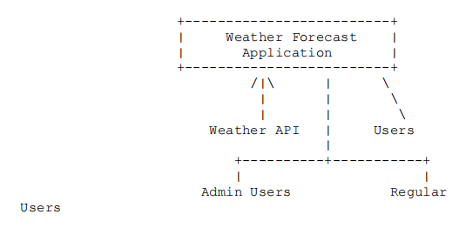

**Level 1 (Detailed DFD)**:

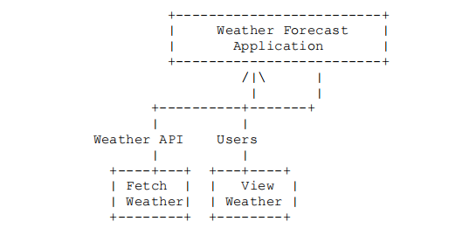

**Structural Diagrams**

*:*

**Component Diagram**: Depicts the components and their interactions.

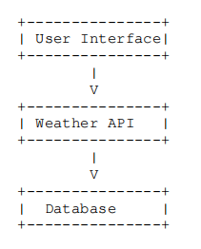

Circuit Diagrams

For a software-based project like this, circuit diagrams are typically not applicable.

However, if integrating with hardware such as IoT devices, a basic circuit diagram

might be included to show how sensors and actuators connect to the system.

+---------------+

| Weather Sensor|

+---------------+

|

V

+---------------+

| Microcontroller|

+---------------+

|

V

+---------------+

| Weather Forecast|

| Application |

+---------------+

This chapter provides a comprehensive overview of the functional and non-functional requirements, data flow, and structural elements necessary for developing a robust Weather Forecast Application. If you need more specifics or additional diagrams, feel free to ask!

**Chapter 3**

**Coding**

This weather forecasting application is designed with a modular structure to ensure

maintainability and scalability. Here’s an in-depth overview of the coding aspects:

**Frontend Components:**

React-Based Architecture: The application’s frontend is developed using React, which allows for the creation of interactive and dynamic user interfaces. The main component (App.js) coordinates child components and manages state transitions.

**Components Structure:**

**Weather Display Component**: Displays fetched weather data, including temperature, weather conditions, and other relevant metrics.

**Search Bar Component**: Handles user input for location search, validates input, and triggers API calls.

**Header and Footer Components**: Provide consistent UI elements across the app.

**Loader Component**: Shows a loading animation during API calls.

**Context Management:**

**theme.context.js**: Manages theme settings, supporting both light and dark modes.

Utilizes create Context() and use Effect() to synchronize user preferences with system settings.

**weather.context.js**: Centralizes weather data state management, handling current

weather, hourly, and daily forecasts.

**API Integration:**

The app fetches weather data from a public API (e.g., Open Weather Map) via functions in the API folder. These functions handle data retrieval and formatting for frontend use.

**Asynchronous Data Fetching**: The use Effect () hook in weather.context.js initiates data fetching when the user updates the location or measurement system.

**Styling and Responsiveness**:

**SCSS:** Used for modular and maintainable styling.

**Responsive Design**: Ensures the app provides a consistent user experience across

devices using media queries and adaptive layouts.

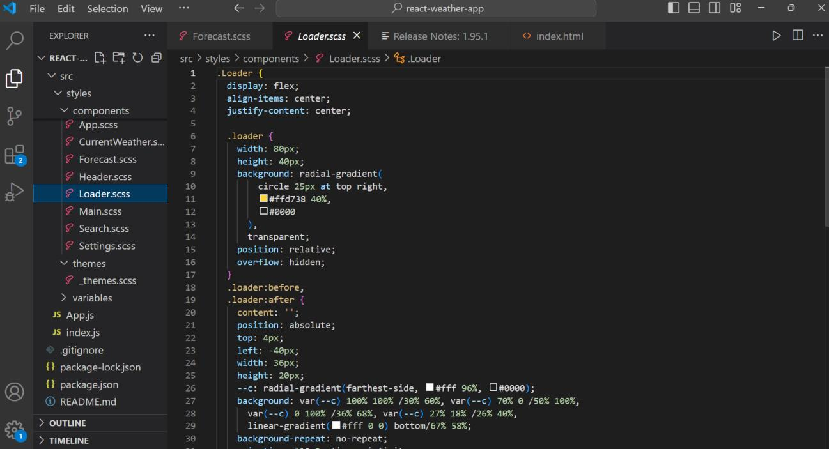

**Validation Checks**

Validation checks maintain the reliability of the application:

**User Input Validation:**

**Location Input**: The Search Bar component ensures non-empty and valid location

entries before making an API call.

**Error Handling**: Implemented in weather.context.js to detect and handle issues

like network errors or invalid API responses.

**User Feedback**: Displays clear error messages when issues occur (e.g., “Location

not found”).

Example Error Handling Code

***Java script***

***Copy code***

***If (! response. ok) {***

***throw new Error('Failed to fetch weather data');***

***}***

**Testing**

Testing strategies to ensure functionality:

**Unit Testing:**

**Component-Level**: Tests for components like Weather Display and Search Bar to

ensure proper rendering and interaction handling.

**Tools Used:** Jest and React Testing Library for running and verifying tests.

**Integration Testing: API and Component**: Verifies seamless integration of API

data with React components.

**State Verification**: Ensures accurate data flow through Weather Provider to

display components.

**Manual Testing**: Conducted across different devices and browsers to ensure cross

browser compatibility and responsive design.

**Snapshots**

**Loading State:** A loading animation or message shown during data fetching

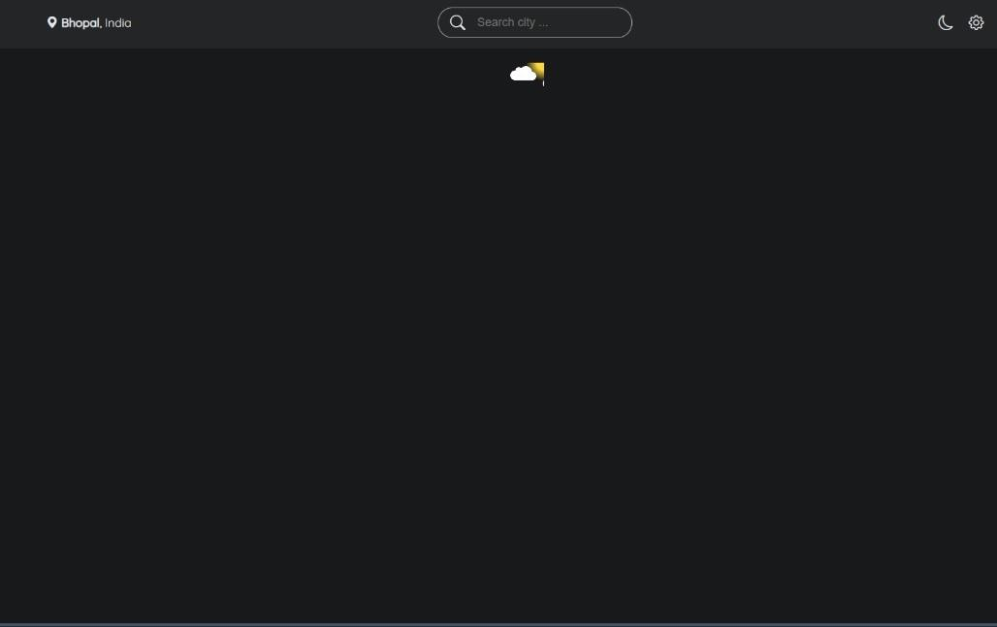

**Weather Display**: Shows data after a successful API response. 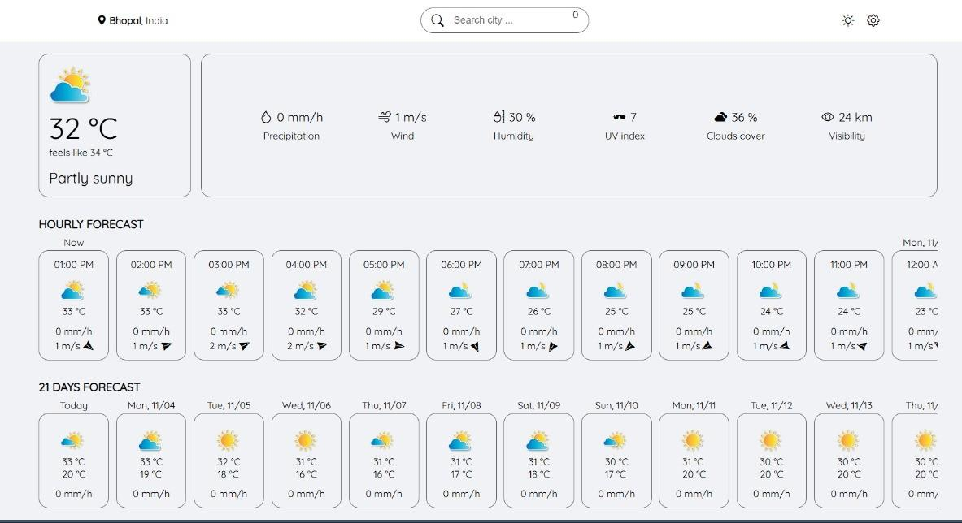

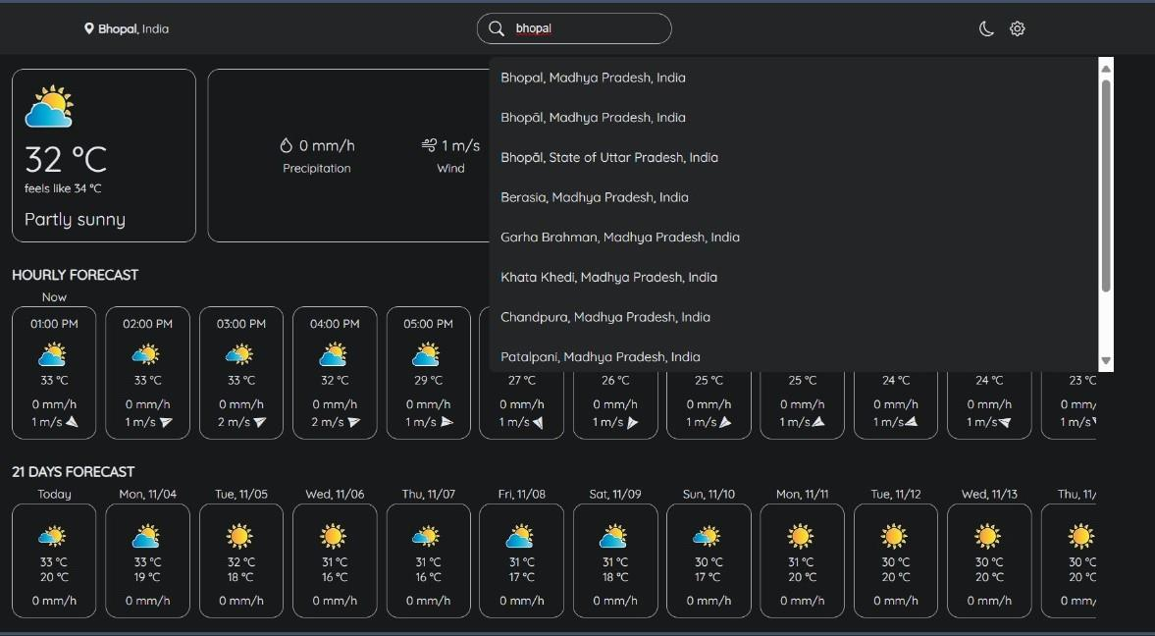

**Error State**: Displays an error message when a location is not found or a request fails.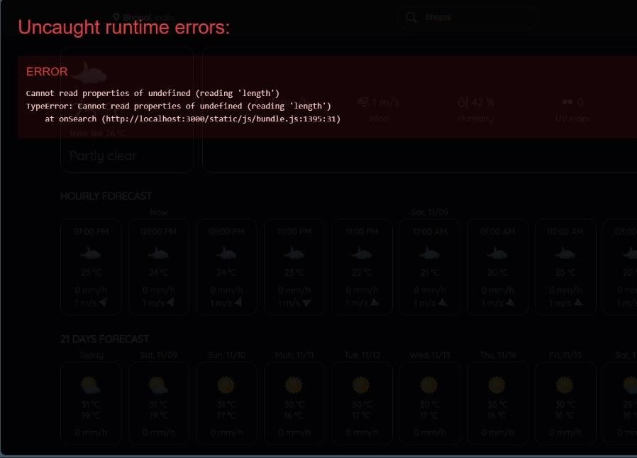

**Source code & API :**

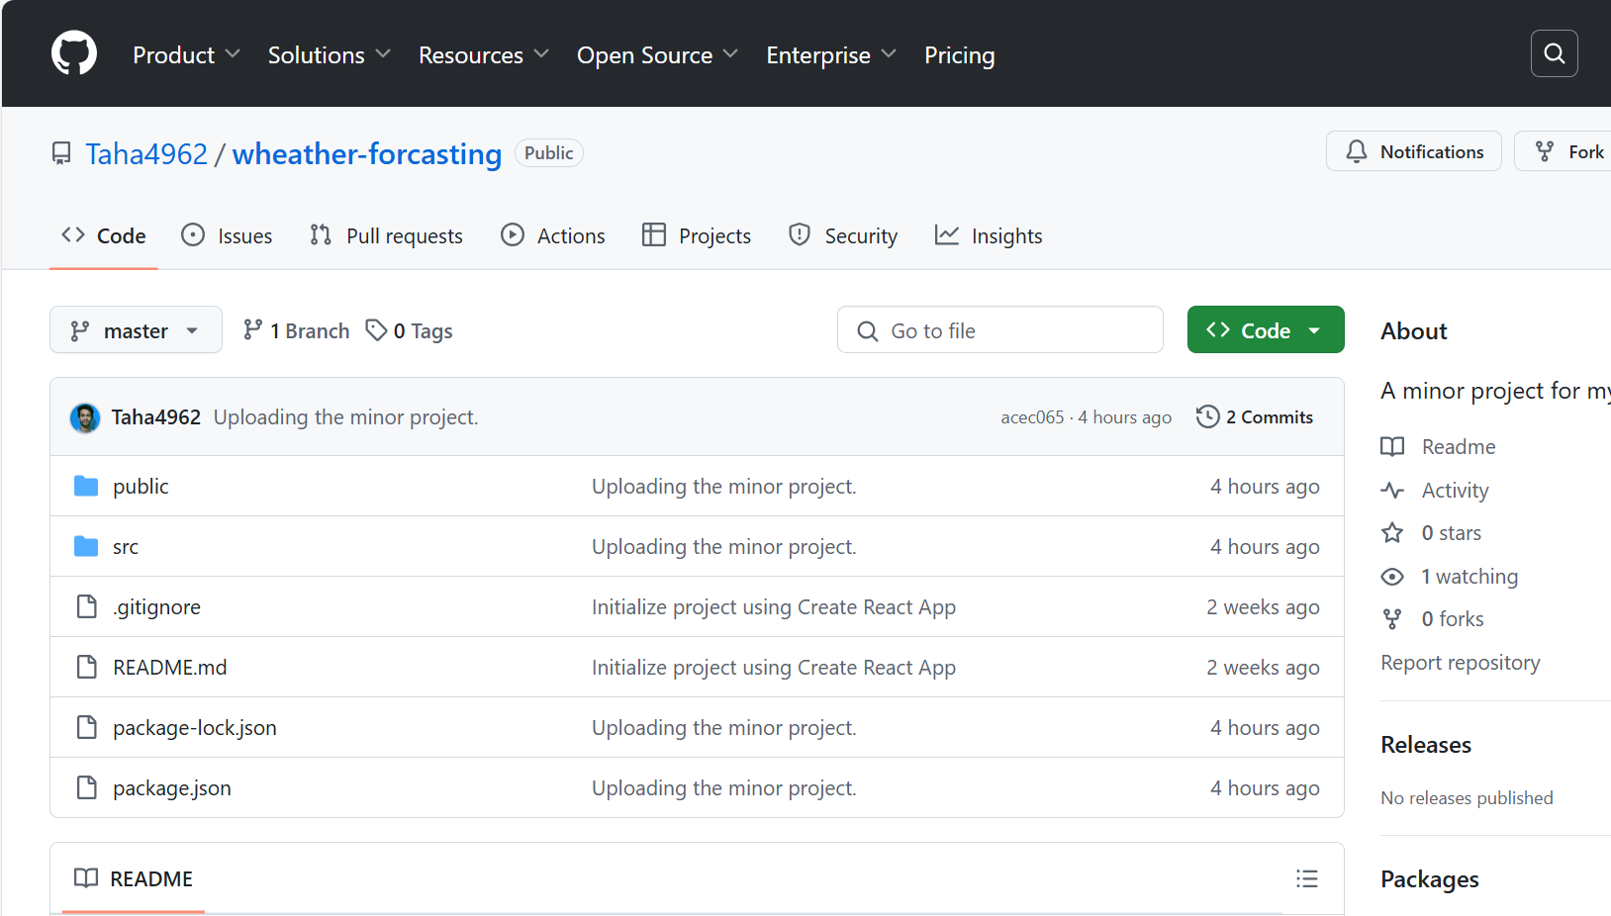

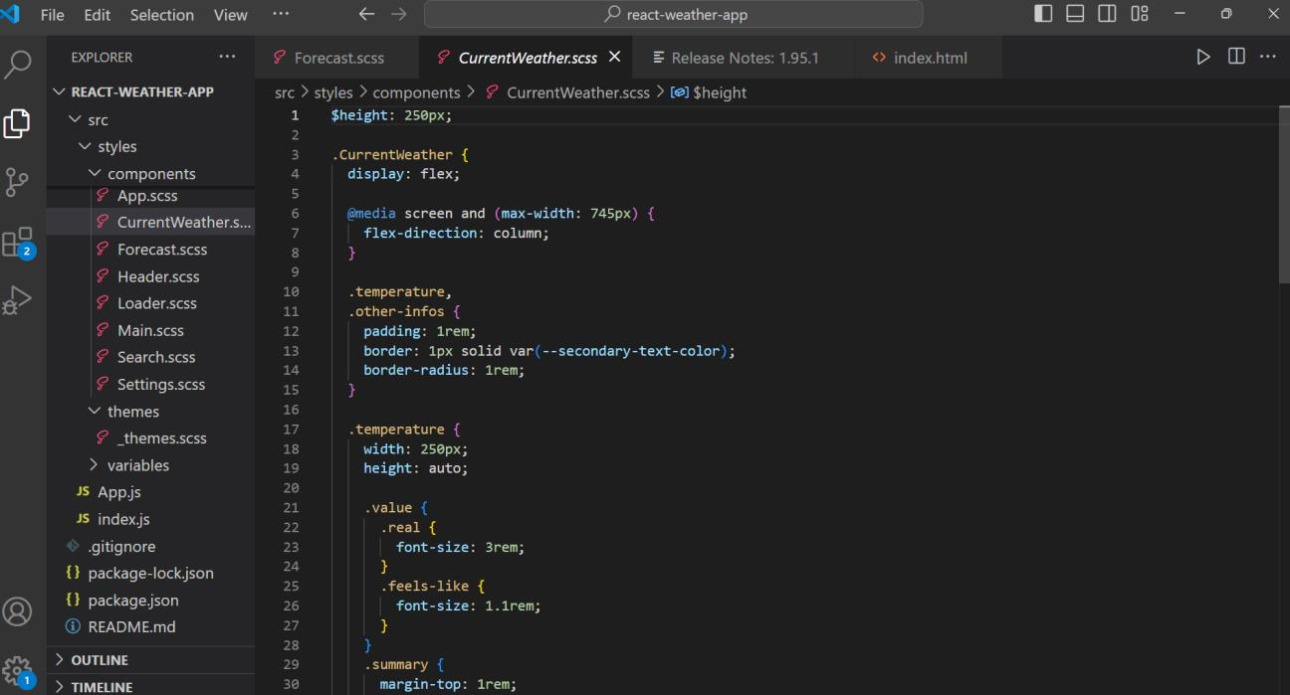

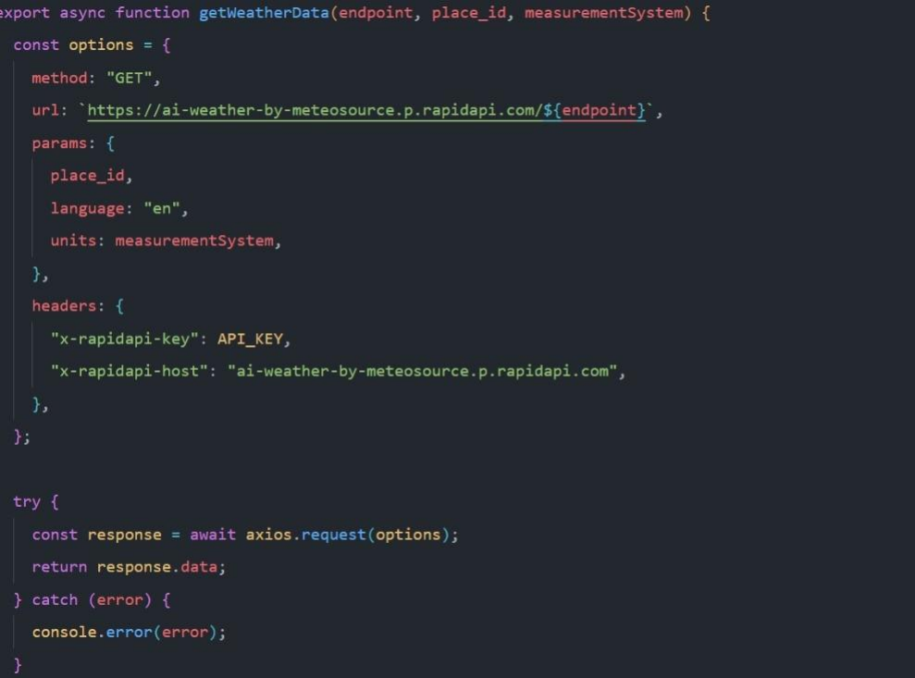

**Chapter4**

**Market Potential & Competitive Advantages**

The market potential for a Weather Forecast Application is significant, given the increasing reliance on weather information for various sectors. With advancements in technology and the growing importance of climate resilience, there is a substantial demand for accurate and timely weather forecasts. The application can cater to inverse users, including individuals, businesses, governments, and farmers, offering tailored services to meet specific needs.

**Accuracy and Timeliness**

Leveraging advanced algorithms and real-time data from reliable sources ensures that the weather forecasts provided by the application are both accurate and timely. The application uses machine learning and data analysis techniques to process vast amounts of meteorological data, including satellite imagery, radar information, and historical weather patterns. This comprehensive approach allows for precise predictions and quick updates, ensuring that users receive the most current information possible. By maintaining high accuracy and providing frequent updates, he application can significantly improve decision-making for its users, whether they're planning daily activities, agricultural tasks, or emergency responses.

**User-Friendly Interface**

The application features an intuitive and customizable interface designed to enhance user experience. The layout is clean and easy to navigate, with clear icons and visual elements that make weather information accessible at a glance. Users can personalize their experience by adjusting settings such as units of measurement (Celsius/Fahrenheit), preferred language, and types of alerts. The interface is also designed to be responsive, ensuring it works seamlessly on various devices, including smartphones, tablets, and desktops. Accessibility features, such as compatibility with screen readers and adjustable text sizes, ensure that the application can be used by a diverse audience, including those with disabilities. By focusing on these competitive advantages, the Weather Forecast Application not only stands out in the market but also provides invaluable support and convenience to its users, enhancing their ability to make informed decisions and stay prepared for any weather-related challenges

**Likely Benefits**

The Weather Forecast Application offers several benefits, including:

*Agricultural Optimization*

For farmers, accurate weather forecasts are indispensable tools for optimizing crop management. The application offers detailed predictions on rainfall, temperature, and other weather conditions that affect planting, irrigation, and harvesting. By using this information, farmers can make informed decisions that lead to better management of resources and timing of agricultural activities. This can result in increased crop yields and reduced losses due to adverse weather conditions, thereby supporting sustainable agricultural practices and food security.

*Improved Transportation and Logistics*

The application enhances safety and efficiency in transportation by providing precise weather information that aids in planning and decision-making. For aviation, maritime, and road transport, knowing weather conditions in advance can help in plotting safe routes, scheduling departures and arrivals, and avoiding delays caused by adverse weather. This leads to smoother operations, reduced accidents, and overall improved logistics. Companies can better manage their supply chains, ensuring timely delivery of goods and services.

*Energy Management*

Accurate weather forecasts are vital for optimizing renewable energy production, particularly for solar and wind power. The application assists energy managers in predicting weather patterns that affect energy generation, such as sunlight and wind speed. By doing so, they can better plan energy production and distribution, ensuring steady supply of renewable energy. This not only supports the efficient use of renewable resources but also contributes to the overall sustainability of the

energy sector.

*Public Health*

The application plays a significant role in promoting public well-being by providing forecasts on air quality and issuing health advisories during extreme weather conditions. Poor air quality can have serious health effects, especially for vulnerable populations such as the elderly and those with respiratory conditions. By predicting pollution levels and issuing timely alerts, the application helps individuals take necessary precautions, such as staying indoors or wearing masks..

*Daily Convenience*

For everyday users, the application greatly enhances the ability to plan daily activities. With reliable weather forecasts at their fingertips, individuals can make better decisions about what to wear, whether to carry an umbrella, or if it's a good day for outdoor activities. This convenience improves overall quality of life by reducing the uncertainty and inconvenience caused by unexpected weather changes. Users can plan their schedules more effectively and be better prepared for

the day ahead.

**Limitations**

Despite its many advantages, the Weather Forecast Application has some

limitations:

*Data Dependency*

The accuracy and reliability of the Weather Forecast Application are heavily dependent on data from external sources, such as meteorological agencies and weather APIs. This reliance means that any disruptions or inaccuracies in the data provided by these sources can significantly impact the application’s forecasts. For instance, if a data provider experiences technical issues or delays in data updates, the application's ability to provide accurate and timely weather information may be compromised. Moreover, the quality and resolution of the data can vary between sources, potentially leading to inconsistencies in forecasts.

*High Computational Demand*

Running advanced weather prediction models and processing vast amounts of real time, data require significant computational resources. These models involve complex algorithms and large datasets, necessitating powerful servers and high processing speeds. The costs associated with maintaining and upgrading this infrastructure can be substantial, particularly for smaller organizations or startups. Additionally, ensuring that the system remains responsive and efficient under high computational loads is a technical challenge that requires ongoing optimization and investment.

*User Adoption*

Convincing users to switch from their current weather services to the new application can be a considerable challenge. Many users may be loyal to existing services they have used for years and trust. Overcoming this inertia requires demonstrating clear advantages and unique features that set the new application apart. Marketing efforts, user education, and providing a superior user experience are crucial to attracting and retaining new users. It’s essential to offer compelling reasons for users to make the switch, such as more accurate forecasts, better interface design, or additional services not available in other applications.

*Geographical Coverage*

The availability and quality of weather data can vary significantly across different regions. Some areas, especially remote or underdeveloped regions, may have limited meteorological infrastructure, leading to sparse or less reliable data. This limitation affects the accuracy of forecasts in those regions, making it challenging to provide the same level of service globally. To address this issue, the application may need to integrate multiple data sources and utilize advanced interpolation techniques to fill gaps, but these solutions may not fully compensate for the lack of direct observations.

**Future Scope**

The future scope for the Weather Forecast Application includes several exciting

possibilities:

*Advanced AI and Machine Learning*

Integrating more sophisticated AI and machine learning techniques can significantly enhance the prediction accuracy and personalization of weather forecasts. These advanced algorithms can analyze vast amounts of historical and real-time data to identify patterns and trends that may not be immediately apparent. Machine learning models can continuously improve by learning from new data, leading to more precise short-term and long-term weather predictions. Personalization features can be developed to provide users with tailored forecasts based on their specific locations, preferences, and activities, making the application more relevant and user-centric.

*Global Expansion*

Expanding services to cover more geographical areas, particularly underserved regions, can increase the application's user base and its societal impact. By incorporating data from additional sources and enhancing the infrastructure to support global coverage, the application can provide accurate weather forecasts to regions that may currently lack reliable weather information. This expansion can help communities worldwide prepare for and respond to weather conditions, ultimately improving global safety and quality of life.

*Integration with IoT Devices*

Enhancing data collection and providing more localized forecasts can be achieved by integrating with Internet of Things (IoT) devices, such as personal weather stations, smart home devices, and wearable technology. These devices can collect and transmit hyper-local weather data, improving the accuracy and relevance of forecasts for specific locations. For example, a network of home weather stations could provide real-time data on temperature, humidity, and rainfall, allowing the application to offer highly localized predictions and alerts. Integration with smart home systems can also enable automated responses to weather changes, such as adjusting thermostats or activating irrigation systems.

*Climate Change Adaptation*

As climate change continues to impact weather patterns, the application can play a crucial role in helping communities and businesses adapt. By offering tools and services specifically designed to address the challenges posed by climate change, the application can support resilience and preparedness. Features might include long- erm climate forecasts, risk assessments for extreme weather events, and recommendations for mitigating the effects of climate change. Businesses can use this information to develop strategies for continuity and sustainability, while communities can plan infrastructure improvements and emergency responses.

*Enhanced User Engagement*

Developing features that increase user engagement and retention is vital for the application's success. Interactive maps can provide users with a visually appealing way to explore weather data, while weather-related games can make learning about weather patterns fun and educational. Educational content, such as articles, videos, and tutorials, can help users understand the science behind weather forecasts and the importance of weather preparedness. By offering these engaging features, the application can build a loyal user base that regularly interacts with and benefits from he service. Incorporating these advancements and features into the Weather Forecast Application can significantly enhance its functionality, accuracy, and user experience, ensuring it remains a valuable tool for users worldwide.

**Conclusion**

The Weather Forecast Application has significant market potential and offers numerous competitive advantages that can greatly benefit various sectors. While there are some limitations, the application’s future scope holds promising opportunities for growth and improvement. By continuously enhancing its features and expanding its reach, the Weather Forecast Application can become an indispensable tool for users worldwide, helping them navigate the complexities of weather and make informed decisions.